

Programme Name: ________**BCS HONS**_______________________________________

Course Code: __**CSC 2330** _______

Course Name: ___**Software Project Management**_____ ______________________________

**Internal Examination**

Date of Submission: ______**1/18/2020**_____________

**Submitted By: Submitted To:**

Student Name**: Dipesh Tha Shrestha** Faculty Name**:** **Satyam Paudel**

IUKL ID: **041902900028** Department**: LMS**

Semester**: Third Semester**

Intake**: September 2019**

1. Perform a financial analysis of a project assuming that the projected costs and benefits for this project are spread over four years as follows:

Estimated costs and benefits are given below.

Use an 8 percentage discount rate, round the discount factors to two decimal places.

|  |  |  |  |  |
| --- | --- | --- | --- | --- |
| Discount rate | 8% |  |  |  |
|  | Year 0 | Year 1 | Year 2 | Year 3 |
| Costs | 1,40,000 | 40,000 | 40,000 | 40,000 |
| Benefits | 0 | 2,00,000 | 2,00,000 | 2,00,000 |

* 1. Create a financial template on the paper to calculate Discount Factor, Discounted Cost and Discounted Benefits for each year.
  2. Calculate Net present Value .
  3. Calculate Return on Investment (ROI).

1. marks)

* 1. Calculate the year in which the payback occurs.

1. marks)

* 1. Suggest whether you would recommend investing in this project with the justification

Answer:

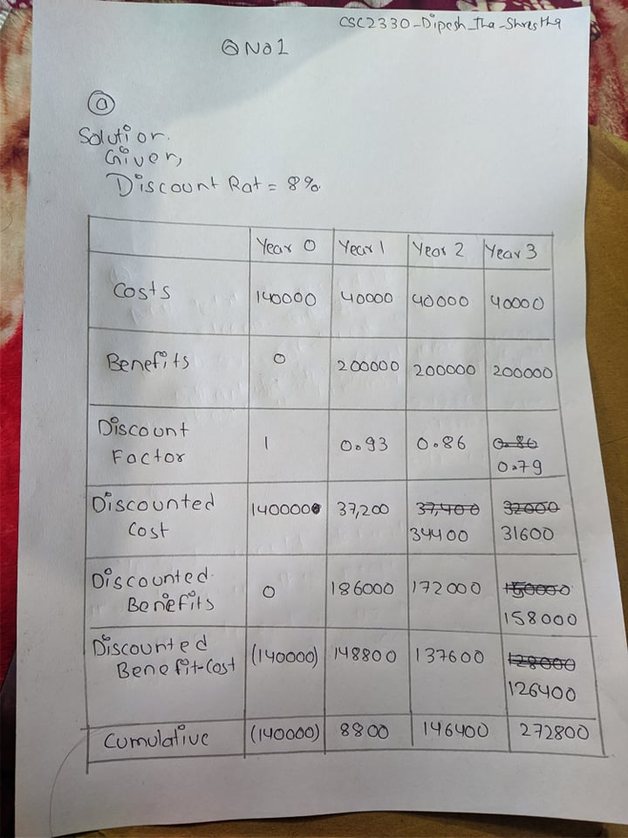

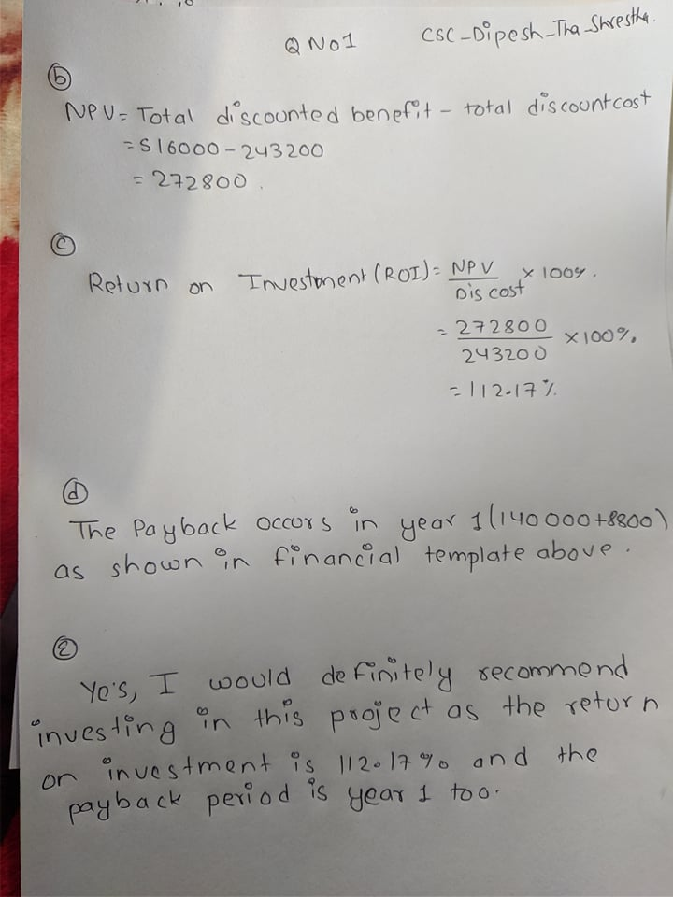

1. Assume that you have completed three months of the project. The BAC was $200,000 for the six-month project. You can also make the following assumptions:

PV= $120,000

EV= $100,000

AC= $90,000

* 1. Calculate Cost variance.

(2 marks)

* 1. Calculate Schedule variance for the project.

(2 marks)

* 1. Calculate the Cost Performance Index.

(2 marks)

* 1. Calculate the Schedule Performance Index.

(2 marks)

* 1. Calculate the Estimate at Completion.

(2 marks)

* 1. Estimate how long it will take to complete the project.

(2 marks)

* 1. Is the project performing better or worse than planned? Is it behind or ahead of schedule? Is it under budget or over budget?

(3 marks)

Answer:

